Software Architecture Research and Development Project Synopsis
Building product lines from existing software
Department of Computer Science, University of Aarhus
Aabogade 34, 8200 Århus N, Denmark
Group: Bravo
20074842, Lars Kringelbach, lars@kringelbach.com
20064684, Marjus Nielsen, Marjus.nielsen@gmail.com
20074877, Morten Herman Langkjær, morten.herman@gmail.com
20054680, Peter Madsen, pm@chora.dk

<<Date: August 28, 2008>>
Abstract
This document contains the synopsis for an architecture research and development project, which is the final part of the Master in IT course “Software Architecture in Practice”. The main focus of the project will be the task of converting existing software into a software product line.
jeg tror vi kan skrive at vi vil lave en manuel rekonstruktion, og eventuelt kigge på at sammenligne med den rekonstruktion magicdraw eller hvad det hedder har skabt, og dermed få lidt tryg på snakken omkring semiautomatisk rekonstruktion, hvad siger i til det, bliver det for omfattende

1 Product lines

Introduction

What is a product line?
[Clements and Northrop, 3] defines a product line as:
“A set of software-intensive systems sharing a common, managed set of features that satisfy the specific needs of a specific market segment or mission and that are developed from a common set of core assets in a prescribed way.”
According to this definition the products that a product line consists of are “software-intensive”. It must be argued that this definition must also be true for systems having nothing at all to do with software. In fact many historians trace the product line concept to the way that Eli Whitney manufactured rifles using interchangeable parts. This was in the early 1800s, long before the software was used.
The scope of this paper is software product lines and thus the definition used throughout the paper will be as [Clements and Northrop, 3] defines.
The most important fact in this definition is that it specifies that systems are developed from a common set of core assets in a prescribed way. The fact that the products need to have a set of core assets that are common to all of them means that a set of similar products developed separately are not a product line but only a set of similar products.
In addition to this the definition states that a product line must target a specific market segment or mission. This requirement is discussed later in the chapter on ‘Product Line scoping’.
hmm. vi diskuterer vil emner indenfor rammerne af pensum/teori, så er spørgsmålet vor vidt vi rent faktisk er i stand til at evaluere selve den effort der er lagt i konverteringen, og kan man i det hele taget udtale sig generelt på baggrund af et relativt simpelt OpenSource system

What is not a product line
A good way to clarify what a product line is, is to describe what is not, so the following is a brief description of software development approaches, which are often mistaken for product lines:
- Component-based or service-based development only
Even though many software product lines rely on a form of component-based (or service-based) development, this type of development doesn’t make a product line. In order to become a product line these components must all be specified by the product line architecture. The components must also contain variation points making them adaptable to specific products.
- Single-systems with reuse
This approach is about cloning an existing system (e.g. making a copy of the source code etc.) modify and add to it as needed to create the new product. Clearly a part of another system has been reused, but it is not a product line, but two different systems, not two systems built from the same core assets. It is the experience of the authors of this paper that this approach is widely used and might be viable in some scenarios. A discussion of pros and cons will be part of the discussions section at the end of this paper.
- Releases and versions of single products
New versions and releases of a product are typically based on the same assets, architecture, components, tests etc. from earlier releases. This is in contrast to a software product line, which has multiple simultaneous products most likely having their own release and version plans.
- Component level reuse
The opportunistic reuse of small pieces of code, algorithms, modules etc. stored in a common library shared by developers, as opposed to a product line where the reuse is planned, enabled, and enforced.
- Development standards
Development standards might specify the choices that can be made. E.g. the forced use of a specific framework, database server, vendor etc. A product line might need to conform to such standards, but they are simply constraints not a product line.

Core assets
The core assets are reusable artifacts and resources that form the basis for the software product line. The following are typical examples of core assets:
- The architecture
- Performance measurements and real-time modeling
- Reusable Components
- Requirements
- Documentation and specifications
- Test plans and test cases
The list above shows the most prominent examples only and many other artifacts might be considered as core assets. Other assets might include performance models, COTS software etc. Management related items such as plans and budgets might also be candidates.
These other artifacts will not be considered as part of this paper.
The following is a short discussion of the different artifacts and how they relate to the software product line.

Architecture
The architecture represents a large investment from the architects, which are a limited resource in many organizations, so using the same architecture for multiple products will put less strain on a typically limited resource.
The required qualities like performance, reliability, modifiability, security etc. are a result of specific architectural decisions and tactics and as a result of this these qualities are anchored in the architecture. The specific architecture is used for all products and as a result of this they get the same qualities, thus minimizing risks.
Please note that quality attributes might be varied between products in a product line, e.g. the basis version might only support a single processing unit, while the enhanced version supports multiple processing units thus enhancing performance. The difference here is that the specific product line architecture supports variability on specific qualities, enabling different levels of quality in the individual products, but the quality of the product line architecture itself remains constant.

Performance measurements and real-time modeling
Existing measurements of performance associated analyses are candidates for product line core assets. When building new products from the product line, these measurements give high confidence that any timing-, concurrency-, network load- and deadlock issued have been eliminated.

Reusable Components
A high percentage (Up to 100%) of the components in the core asset base is used in the individual products. Components might require some alterations to fit the specific product, but the design, data structures and algorithms of the components in the core assets base is intact.
Product specific components needs development in order to provide functionality specific to the individual products, but these will be product specific assets, not core assets and will follow a lifecycle mainly independent of the core components. (The lifecycle of product lines will be discussed in detail later).

Requirements
A set of common requirements for the product line is a core asset as they are applicable for all products. In addition to these product specific requirements might exist, stating where the requirements for the specific product differ from the common requirements. Getting the major parts of the requirements from an already established common base means that feasibility studied etc. are automatically inherited, leaving only the analysis of the product specific requirements.

Documentation and specifications
As the full architecture and the common components are inherited in individual products, any documentation and specifications regarding these artifacts are inherited to, and thus should be part of the core assets. The benefit when building a specific product is that only product specific functionality and artifacts needs documentation work.

Test plans and test cases
During the development of the product line, testing artifacts like test plans, test cases, test data, test harnesses, integration- and unit tests are (or at least should have been) developed. Means to report and fix problems have already been used and proved. When building a new product the testing artifacts only need to be tailored to the product specific variations.

Cost and benefits of product lines
As seen in the sections above product lines introduces some overhead by preparing and maintaining core assets and creating an architecture tailored for variability, but it also introduces savings in time and effort when building additional products. Figure 1 from [McGregor, Northrop, Jarrad & Pohl, 4] presents an analysis showing that the total cost of building a product line as opposed to building individual products normally breaks even when building the third product, meaning that if only building two products, using an individual product strategy will most likely be the most cost effective and when building four or more the product line approach will most likely be the most cost effective. This number is of cause a typical number calculated as a mean from multiple projects, and special circumstances might set the break even higher or lower.
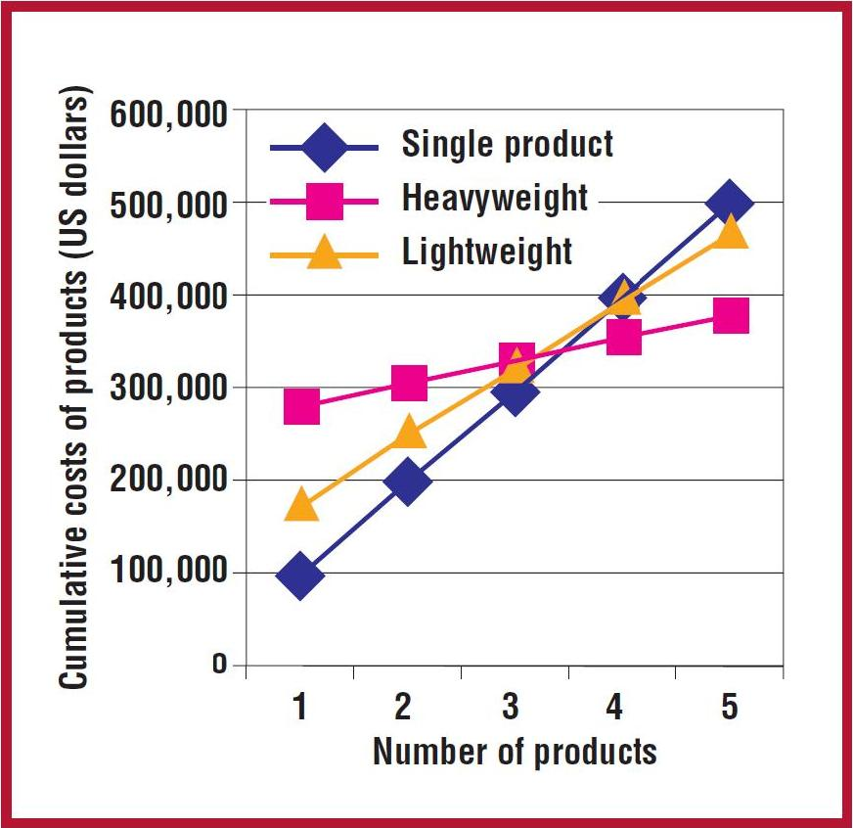
Figure 1 - Benefits of product lines
The figure shows the cumulative costs for individual product development (blue line) and two different product line development strategies (yellow- and pink lines). As the figure shows two different approaches to product lines exists as described below.
Heavyweight
A heavyweight product line is based on a proactive strategy where the reusable core assets are created before any products. The product line is designed and build from the ground up, with no constraints from existing products.
Lightweight
A lightweight product line is based on a reactive strategy, where core assets are extracted from one ore more existing product(s). As a result of this the product line will be constrained by the assets of the donor project(s), which might limit the quality of the resulting product line. The effort in building the product line will be less using this approach, but so is the potential reuse.
An interesting conclusion can be drawn from the figure. It appears that a lightweight approach will never be the optimum solution. When building less than three products, the figure shows that the single product approach is the most cost effective; above three the heavyweight product line approach is the most effective, meaning that the lightweight solution is never the optimal solution.
The following is a short presentation of the costs and benefits normally associated with product lines.

Costs
The costs in building a product line comes down to building the core assets. These assets are also needed for individual products (e.g. an individual product also need an architecture, requirements etc.), but extra work will need to into building these, in order to make them sufficient for supporting a product line. In addition to this the work of tailoring the individual will be added to the total cost.

Benefits
Main parts of the assets needed to build a specific product come from the product line core assets, reducing the cost of producing a product when a product line is in place. As seen in the figure above the total savings increase with the number of products build. In addition to benefits on the project level, the case studies in [Clements and Northrop, 3] shows that organizational level benefits can also be achieved including:
- Ability to sustain unprecedented growth
- Decreased time to market
- Decreased product risk
- Increased market agility
- More efficient use of human resources
- Increased product quality

Cost and benefits of specific core assets
The following table lists core assets and their benefits for a product line and the added costs they will put on the product line.
Asset | Cost | Benefit
Architecture:  The architecture for the product line. | The architecture must support the variation required by all products in the product line. This adds additional requirements to the architecture and adds to the efforts and skills required by the architect. | The architecture represents a large investment from the architects, so using a product line architecture for multiple products will put less strain on a typically limited resource, as the architecture is largely completed for subsequent products.
Performance measurements and real-time modeling:  Products with real-time or near real-time performance requirements, performance measurements and real-time modeling are needed to ensure that requirements are met. | If these artifacts are to be reused, it puts the constraint on the product line that variability cannot exist where performance and real-time behavior is affected. If in doubt a new analysis of (parts of) the product line needs to be performed. | When building new products from the product line, these measurements give high confidence that any timing-, concurrency-, network load- and deadlock issued have been eliminated.
Components:  The software components are the building blocks for the products in the product line. | The components must be designed for reuse. They must be robust and should support variability points and be easily extensible. In order to make components fit multiple products they also need to be general in nature. All in all these additional requirements adds to the development time of the core components. | Typically the interfaces are reused directly, as are most of the components.
Requirements:  Common requirements for the product line. In addition to these product specific requirements might exist | Specifying the requirements for a product line will require an extra analysis effort, and it might be difficult to conclude on both common requirements and variation points that are applicable to all (planned) products. | Common requirements and variation are documented explicitly, which aids in developing the product line architecture. When building new products, they will be much simpler to specify, due to reuse of large parts of the requirements.
Documentation and specifications:  Documentation for the product line architecture and components. | The product line must be well documented, including additional subjects like scoping, use of variability points etc. adding to the effort needed. | The benefit when building a specific product is that only product specific functionality and artifacts needs documentation work.
Test plans and test cases: Testing artifacts for the entire product line. | All artifacts must support more than one product and support variation among the products. | Testing artifacts like test plans, test cases, test data, test harnesses, integration- and unit tests have already been developed. When building a new product the testing artifacts only need to be tailored to the product specific variations.
People and skills:  All staff working on the individual products is also working on the product line. | All staff must understand software product line practices and how to use the core assets. This might require special training and extra documentation and specifications. | The individual products have so much in common that staff working on one product can easily work on another. Even though a product line approach might require extra training, the knowledge gained can be used when developing subsequent products.

Building product lines
Three main activities take place when building a software product line:
- Core assets development
- Developing the products using the core assets
- Management
The order in which the activities are performed depends on whether a lightweight or heavyweight approach is used.
Even when using a heavyweight approach, development of specific products might result in adjustments to the product line architecture.

Core assets development
The core assets are build to facilitate developing products. As described in [Clements et al. 2002] this is an iterative process, where the core asset might influence the context it was build from, e.g. changing the product line scope (se the section below for details) will change the context of which classes of systems to analyze.
The main contexts constraining core asset development are:
Product constraints
Common features and variations in the products, future feature requirements, standards to follow, interfaces to existing systems, quality requirements etc.
Production constraints
Time to market, production capability, standards to follow etc.
Production strategy
Heavyweight or lightweight, in-house development or use of COTS components, automatic generation of products or manual assembly etc.
Preexisting assets
Legacy systems, existing products, libraries, frameworks, algorithms, tools, components etc.

Scoping
The scope of a product line defines which products are to be build as part of the product line. What commonalities do the products have and what are the variations. Normally a feature is clearly part of the product line and other functionalities are clearly not. In between these boundaries a “grey area” exist, where the decision whether to include the feature or not is decided on a case by case basis. The decision to include “gray-area” functionality will typically be motivated by the wish to enter new markets, measure up to the competition etc.
When discussing product line scope, the literature distinguishes between narrow- and broad scope product lines as follows:
Narrow scope
Narrow scope product lines vary only in a relatively small number of features, and are good candidates for specification of new products by means of specialized tools or domain specific languages. In the extreme case individual products can be build by configuration only. Specifying too narrow a scope might be a problem as too few products can be build from the product line to justify the effort.
Broad scope
Broad scope product lines vary both in kind and in features. This gives the possibility of building many different products from the same product line. Broad scoped product lines are typically build as frameworks or a set of services. Specifying too broad a scope can also be problem as the effort needed to build the product line increases when the scope broadens, e.g. building an architecture that supports multiple products with a large number of features, will most likely require a large effort and result in a complex architecture. The task of building the product line might end up being so big that nothing is gained.
Selecting a scope
As seen above getting the scoping for a product line correct is very important for achieving success. As stated in [Bass et. al 2003] it is easy for an architect to find commonalities between systems, but the real problem when scoping is to find the commonality that can be used to reduce costs in a substantial way.
Other items than the products themselves should be considered when scoping. Thinks like market segmentation and target users might be used to determine product lines. E.g. Sony Ericsson has a Walkman phone product line targeted towards young people and a Personal Information Manager phone product line targeted towards business use.
The scope of the product line is not static but will typically evolve as market conditions change, as new opportunities arise, or as the capabilities of architects and tools evolve.

Building the core asset base
The core asset base is the basis for the production of products in the product line. It might not be that all core assets are used in all products, put to qualify as a core asset the artifact must be used in a sufficient subset of the products to justify the effort gone into making it. [Clements et al. 2002] advises that each core asset should have a process description on how they are to be used when building products.
As stated earlier several artifacts can go into the core asset base, and the scope has just been identified as important. In addition to the scope, the architecture is central to the product line.

Product line architecture
The product line architecture plays a key role in the product line, as software architecture supports concepts of having constant as well as varying functionality, which is the essence of a software product line. It is the responsibility of the product line architecture to identify the allowed variations as well as providing mechanisms for achieving them. The variations might be extensive as the products might vary in behavior, quality attributes, platform etc. As stated by [Bass et. al 2003] the tasks of the architect when designing an architecture for a product line are:
- Identifying variability points
- Supporting variability points
- Evaluating the architecture

Identifying variation points
Variation points might be identified at various stages of the product line development, typically during requirement specification and architecture developments, but some might also be identified during implementation, even when building subsequent products.
Some variability points might be interdependent, e.g. the user interface might be tied to the platform, using Windows Mobile as the platform will require one user interface and Windows Vista another.

Supporting variation points
Multiple techniques for supporting variability exits as discussed in [Bass et al. 2003]:
- Inclusion or omission of elements by parameterization of build procedures.
- Using a different number of repeatable elements, e.g. increasing performance by adding mere servers.
- Programming to an interface and then changing the implementation to achieve the desired availability. Selection of the specific implementation can either be done at compile time or at run time by means of some configuration. This can be done by means of static- or dynamic link libraries.
The techniques above are changes on the architectural level, but variability can also be build into individual elements:
- Specialization and generalization of classes
- Overloading methods
- Building extension points into components.
- Using build time parameters (e.g. compiler directives)
- Using reflection (requires programming language support)
Specific architectural patterns or styles support product line development (as do some design patterns). These are described later in this document.

Evaluating the architecture
As a number of systems rely on the product line architecture, the evaluation becomes very important. Evaluation can be done using normal evaluation techniques like ATAM, CBAM and aSQA.
When evaluating focus should be on the variability points, ensuring they are appropriate and supports the planned products. The different quality requirements must also be evaluated.
The product line architecture should of cause be evaluated prior to starting building products, if quality attributes for product varies substantially, specific evaluations might be needed.
When assessing whether to build a product that is in the “gray area” of scoping, the architecture could be evaluated in respect to its suitability to support this new product.

Management
Management is important when developing a product line. The required resources must be assigned, and the product line activities must be coordinated and monitored. It is essential that management at all levels is committed to building the product line.
Management at the organizational level must ensure that an organization capable of building a product line is in place, both in numbers and in skills. They also typically drive the scoping and release plans.
Technical management is responsible for the development of the core assets and products and that processes are followed.

Relationship with the Architecture Business Cycle
One of the main focuses of [Bass et al. 2003] is the Architecture Business Cycle or ABC, which talks about the software architecture being a result of technical, business and social influences, where these influences influence the architect and thus the architects work. The knowledge gained by the architect and the work produced will again influence the organization and so on. This cycle will keep running over time.
This also applies to product lines in particular, where the ongoing development of a product line with producing new products, adjusting the core assets due to the knowledge gained, which leads to new product etc., is an example of the architecture business cycle, where more knowledge on building product lines is gained by the organization over time. Educating staff in product line practices will also result in gained product line knowledge and acceptance within the organization, resulting in better education. Many of these cycle effects might exist when building product lines.
Influence might not always be positive. Problematic experiences with product lines might lead to the organization not supporting the effort wholeheartedly, resulting in more problems etc., so ABC effects are quite prominent when discussing product lines.

Organizational requirements
As stated in the Motivation section, organizational support is very important in order to build a successful product line. Management need to accept that building the product line adds a development overhead, resulting in not being able to deliver the first product as soon as normally expected when building the products individually.
As all initiatives that involve large parts of an organization, it is of greatest importance that the full organization understands and supports the effort, and that the organization does not give up at the first sign of problems. [Clements et al. 2002] recommends that an individual or group should be assigned as product line with the responsibility of keeping the organization pointed toward the product line goals, in order to keep the organization on track even if problems are encountered.
Collecting, maintaining and maturing the core assets require discipline and maturity from the organization. Assets needs to be managed, documented and process descriptions on their use need to be developed and documented. Not all organizations are capable of marinating a continuous high standard in these non-coding related fields.
A product line development needs a well trained staff, the skills of the architect are crucial here, as the architecture of a product line is different to single product architectures, and might potentially be large and complex if a broad scope product line is developed.
References
[1] http://sourceforge.net/projects/drinkmixer/
[Bass et al. 2003] L. Bass, P. Clements, and R. Kazman. (2003) Software Architecture in Practice 2nd Edition. Addison-Wesley, chapter 14 and 15
[Clements et al. 2002] Clements, P. and Northrop, L. (2002) Software Product Lines.
[McGregor et. al 2002] McGregor, J.D., Northrop, L.M., Jarrad, S., Pohl, K. (2002) Initiating Software Product Lines. IEEE Software 19(4), pp 24-27

